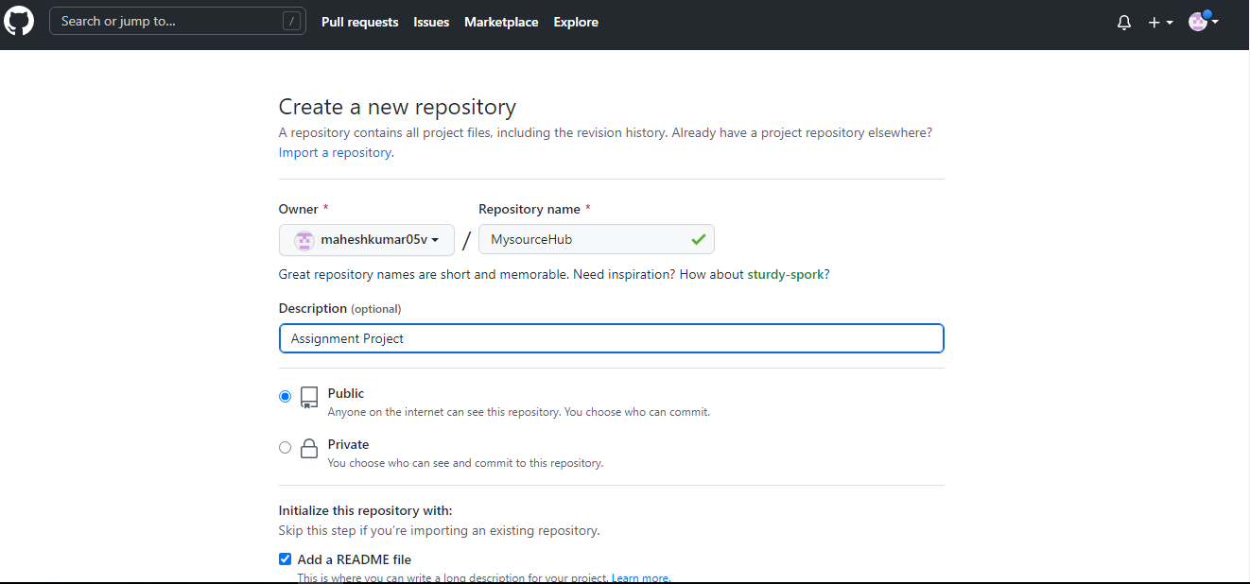

Step 1: Create a Repository as MysourceHub and give public access and add README file create a new repo

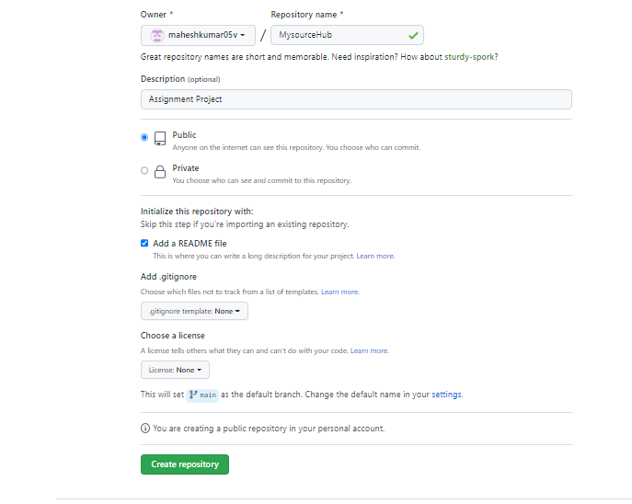

Step 2 : Create a Repository

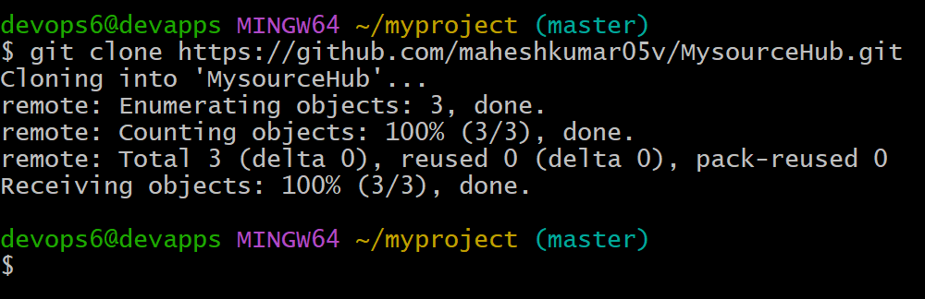

Step 3: Clone the repo into local machine from remote machine

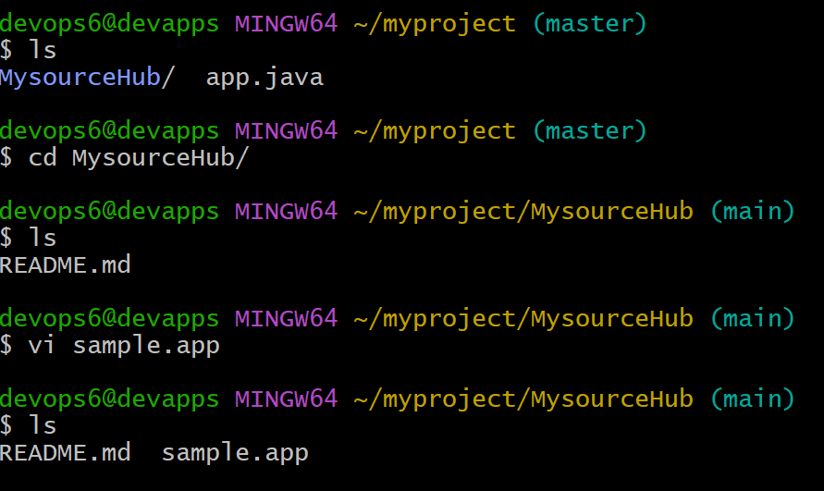

Step 4 : Created one sample application in MysourceHub Dir

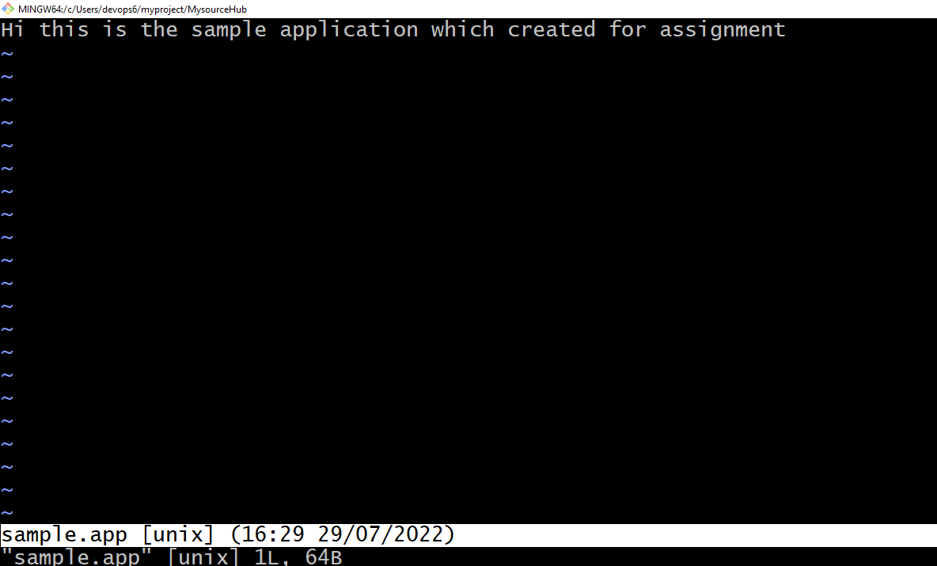

Step 5: Created a sample test file for application

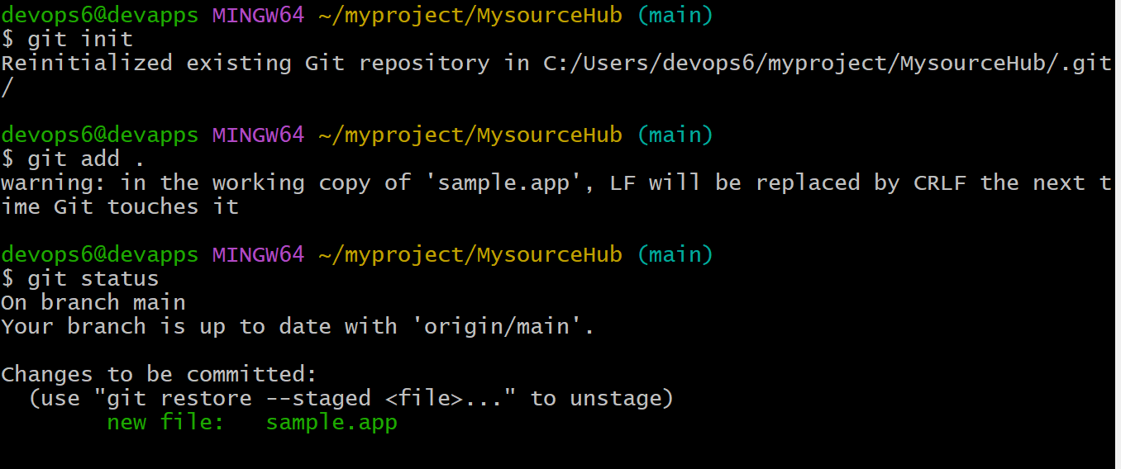

**Step 6:** Then initialized git repo and there are three stages in GIT which can move our filr

Now the file in Working area Git add . then it will go to staging area

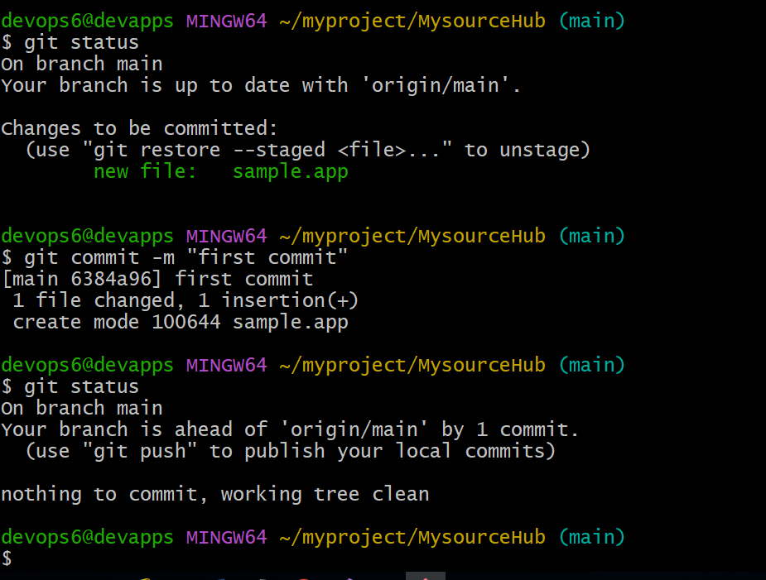

**Step 7:** Now the file is in Staging area we used command **git commit –m “first commit”** so it goes staging to local area

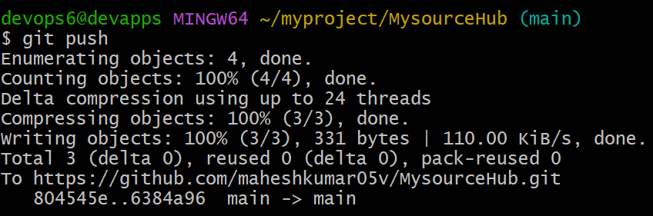

Step 8: Now push the sample application to remote repo by using git push command

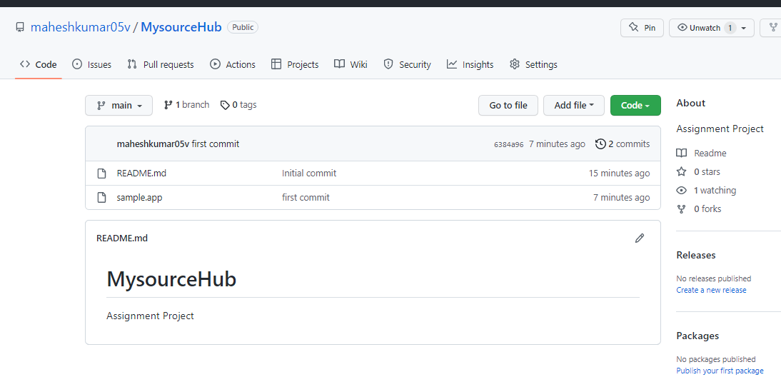

Step 9: Now the file will appear in Remote MysourceHub Repo we pushed the file from local to remote.